# Kaushal Kotkar

**BE-15**

# Roll no: 54

**Experiment No. 3**

**Aim:** To perform the reverse Image analysis for finding the physical location where the content was captured. Use OSINT tool to use image metadata, landmarks, street signs, or other visual cues to identify the geo-location accurately.

**Lab Outcome:** Gather information/metadata about Maps to performance detailed map profiling.

# Theory:

Reverse image analysis refers to the process of extracting information or insights from an image, often by analyzing its visual content, metadata, or other related data. While the term isn't widely used, it can encompass several techniques and theories related to image processing, computer vision, and data analysis. Here's an overview of the theory and techniques involved in reverse image analysis:

Image Processing and Computer Vision: Image processing involves manipulating and enhancing images to extract relevant information. Computer vision goes a step further by enabling computers to interpret and understand visual information. Techniques like filtering, edge detection, and feature extraction are used to process images and identify important elements.

Feature Extraction: In reverse image analysis, feature extraction refers to identifying distinct visual characteristics or patterns from an image. This could include identifying objects, shapes, textures, colors, and more. These features are often used as input for further analysis or classification.

Object Recognition and Classification: Reverse image analysis can involve identifying and classifying objects within an image. This could be achieved through various methods, such as machine learning algorithms like convolutional neural networks (CNNs) or traditional computer vision techniques like template matching.

Metadata Analysis: Images often contain metadata, which is information about the image itself. This could include details such as the camera type, date and time the photo was taken, location, and more. Metadata can provide context and additional information for reverse image analysis.

Reverse Image Search: Reverse image search is a technique where an image is used as input to find similar or related images on the internet. Search engines or specialized tools can match the visual characteristics of the input image to images in their database, potentially leading to the source of the image or related information.

# Output:

Image used for reverse engineering



**TinEye:** Use to find out where an image came from, how it is being used, if modified versions of the image exist or to find a higher resolution version.

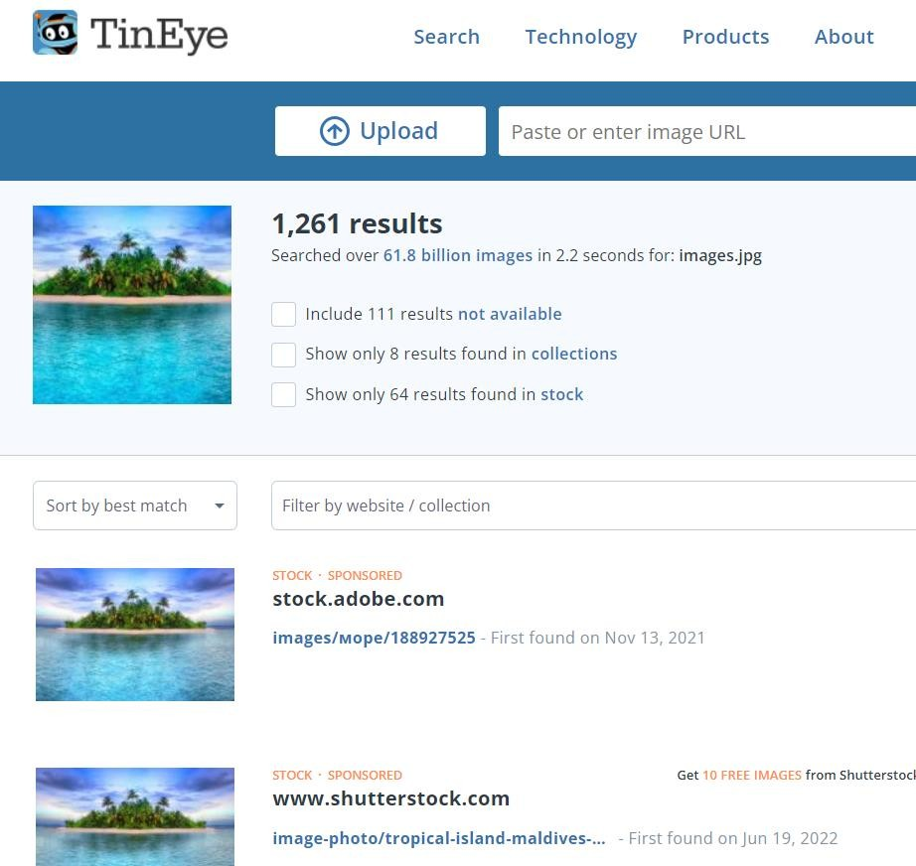

**Exiftool:** Use to find metadata of the images

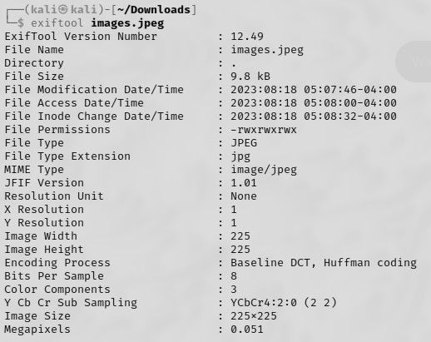

**FotoForensic:** It is used to find metadata and geolocation of an image

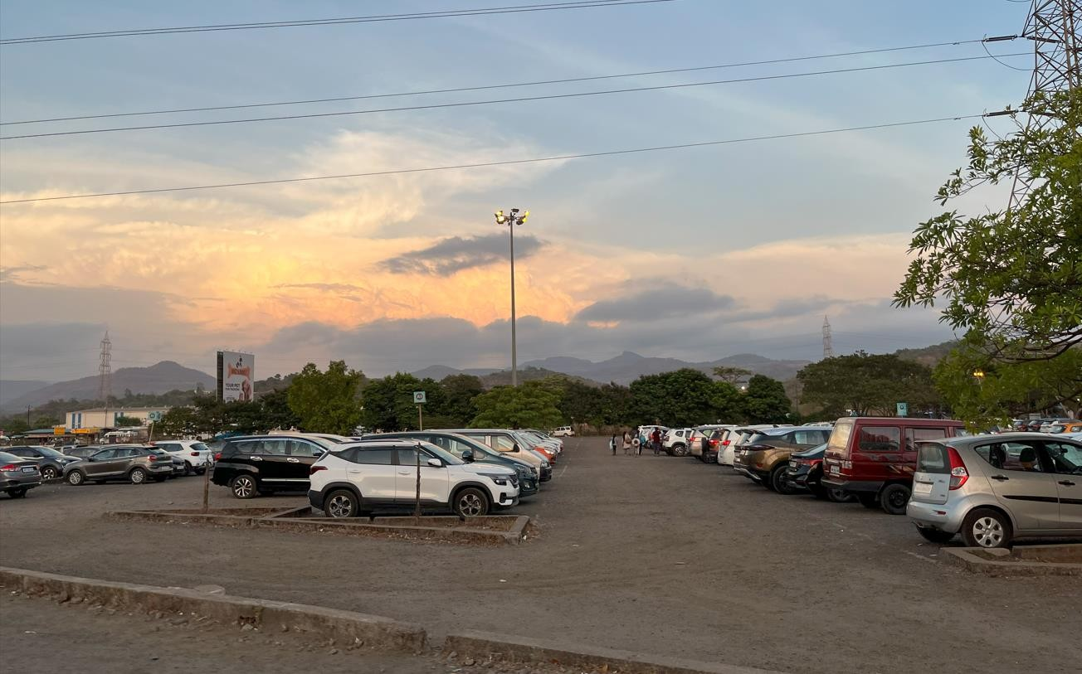

**s**

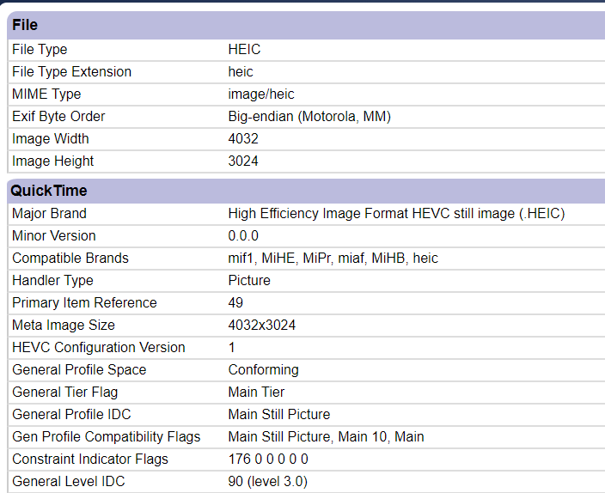

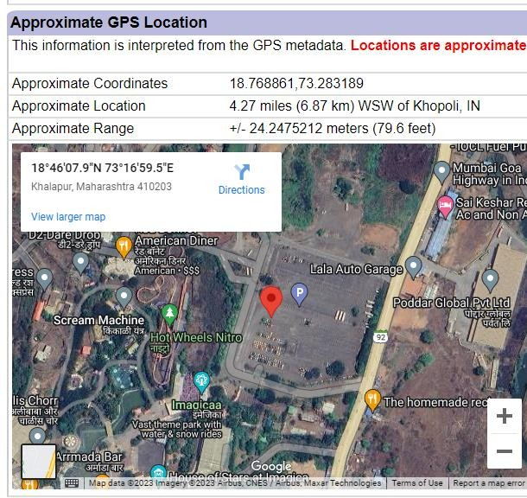

**Conclusion:** Here we were able to perform the reverse Image analysis for finding the physical location where the content was captured using the OSINT tools.